Supplementary Materials
Supplementary Table S1
Item-Level Descriptive Statistics (N = 522)
Item | M | SD | Min | Max | Skew | Kurt
AIP1 | 2.975 | 1.255 | 1 | 5 | −0.069 | −1.021
AIP2 | 2.962 | 1.228 | 1 | 5 | −0.070 | −0.945
AIP3 | 3.071 | 1.126 | 1 | 5 | −0.123 | −0.657
AIP4 | 3.004 | 1.171 | 1 | 5 | −0.036 | −0.851
AIP5 | 3.107 | 1.190 | 1 | 5 | −0.118 | −0.864
PA1 | 3.155 | 1.189 | 1 | 5 | −0.225 | −0.828
PA2 | 3.159 | 1.184 | 1 | 5 | −0.156 | −0.846
PA3 | 3.111 | 1.209 | 1 | 5 | −0.109 | −0.923
PA4 | 3.172 | 1.155 | 1 | 5 | −0.219 | −0.737
PA5 | 3.186 | 1.196 | 1 | 5 | −0.293 | −0.786
DR1 | 3.148 | 1.151 | 1 | 5 | −0.191 | −0.778
DR2 | 3.121 | 1.160 | 1 | 5 | −0.140 | −0.773
DR3 | 3.199 | 1.201 | 1 | 5 | −0.214 | −0.831
DR4 | 3.065 | 1.162 | 1 | 5 | −0.090 | −0.834
DR5 | 3.165 | 1.174 | 1 | 5 | −0.172 | −0.818
FSP1 | 3.021 | 1.348 | 1 | 5 | −0.038 | −1.183
FSP2 | 3.059 | 1.300 | 1 | 5 | −0.058 | −1.077
FSP3 | 3.036 | 1.365 | 1 | 5 | −0.043 | −1.197
FSP4 | 3.057 | 1.329 | 1 | 5 | −0.051 | −1.117
FSP5 | 3.054 | 1.359 | 1 | 5 | −0.047 | −1.161
Note. All items used a five-point Likert scale (1 = Strongly Disagree, 5 = Strongly Agree). Skew and Kurt refer to skewness and excess kurtosis respectively.
Supplementary Table S2
Construct-Level Descriptive Statistics, Reliability, and Inter-Construct Correlations (N = 522)
Construct | M | SD | α | AVE | AIP | PA | DR | FSP
AIP | 3.02 | 1.19 | 0.894 | 0.630 | 1.000
PA | 3.16 | 1.19 | 0.895 | 0.637 | −0.346 | 1.000
DR | 3.14 | 1.17 | 0.884 | 0.618 | −0.331 | 0.296 | 1.000
FSP | 3.05 | 1.34 | 0.877 | 0.584 | −0.655 | 0.596 | 0.641 | 1.000
Note. M and SD are based on raw Likert-scale item scores averaged across items within each construct. α = Cronbach's alpha; AVE = average variance extracted. Correlations are based on Bartlett factor scores.
Supplementary Table S3
Fornell-Larcker Discriminant Validity Matrix (N = 522)
 | AIP | PA | DR | FSP
AIP | 0.794
PA | −0.346 | 0.798
DR | −0.331 | 0.296 | 0.786
FSP | −0.655 | 0.596 | 0.641 | 0.764
Note. Bold diagonal = √AVE. Off-diagonal = latent factor correlations based on Bartlett factor scores. Discriminant validity supported when √AVE > all corresponding inter-construct correlations. Criterion satisfied for all four constructs.
Supplementary Table S4
Harman's Single-Factor Test for Common Method Bias (N = 522)
Principal Component | Eigenvalue | Variance Explained (%) | Cumulative (%)
1 | 8.135 | 40.68 | 40.68
2 | 2.675 | 13.38 | 54.05
3 | 2.618 | 13.09 | 67.14
4 | 0.833 | 4.16 | 71.31
5–20 | < 0.527 | < 2.64 | —
Note. Unrotated principal component analysis on all 20 items. First component = 40.68% < 50% threshold (Podsakoff et al., 2003), suggesting that common method bias does not pose a serious threat to the validity of this study. However, the CFA-based common method factor test indicated a non-trivial fit improvement (ΔCFI = −0.035), which should be considered alongside this result when interpreting the findings.
Supplementary Table S5
Variance Inflation Factors for Model C Predictors (N = 522)
Predictor | VIF | Tolerance
AIP (linear) | 1.375 | 0.727
AIP² (quadratic) | 1.137 | 0.879
PA (linear) | 1.336 | 0.749
PA² (quadratic) | 1.152 | 0.868
DR (direct) | 3.364 | 0.297
AIP × DR | 1.289 | 0.776
AIP² × DR | 2.482 | 0.403
PA × DR | 1.329 | 0.753
PA² × DR | 2.389 | 0.419
Note. All VIF values below the conventional threshold of 10 (Kline, 2016). Maximum VIF = 3.364 (DR direct effect), well within acceptable range. Tolerance = 1/VIF.
Supplementary Table S6
Simple Slopes for the AIP–FSP and PA–FSP Relationships at Three DR Levels (N = 522)
Predictor | Level | Low DR (Q25 = 1.99) | Medium DR (Q50 = 3.03) | High DR (Q75 = 4.03)
AIP → FSP | Low AIP (−1SD) | −0.535 | −0.365 | −0.200
 | High AIP (+1SD) | −0.223 | −0.362 | −0.496
PA → FSP | Low PA (−1SD) | +0.157 | +0.291 | +0.421
 | High PA (+1SD) | +0.410 | +0.325 | +0.243
Note. Slope = predicted change in FSP per one-unit increase in predictor at the given combination of predictor and DR levels. Simple slopes are derived from Model C factor score regression coefficients. AIP SD = 1.249; PA SD = 1.184. DR levels reported on raw 1–5 scale (Q25 = 1.99, Q50 = 3.03, Q75 = 4.03). All slope values are unstandardized.
Supplementary Table S7
Extended Robustness Check Results: Key Coefficients Across Estimation Strategies (N = 522)
Term | Main Model | Outlier-Removed | MM-Estimator
 | b (p) | b (p) | b (p)
AIP² (H1) | −0.006 (0.729) | −0.006 (0.729) | −0.003 (0.893)
PA² (H2) | +0.002 (0.899) | +0.002 (0.899) | +0.000 (0.989)
AIP² × DR (H3) | −0.060 (<0.001) | −0.060 (<0.001) | −0.059 (<0.001)
PA² × DR (H4) | −0.045 (<0.001) | −0.045 (<0.001) | −0.047 (0.003)
DR → FSP (H5) | +0.521 (<0.001) | +0.521 (<0.001) | +0.523 (<0.001)
Note. N = 522 for Main Model and Outlier-removed (zero outliers detected via Mahalanobis distance at p < 0.001). MM = MM-estimator robust regression. Split-sample cross-validation results (calibration n = 365; holdout n = 157) reported in Section 4.5. Sign consistency across all three estimation strategies provides convergent evidence for the stability of H3, H4, and H5.
Supplementary Table S8
Bootstrap BCa 95% Confidence Intervals for Model C Parameters (2,000 Replications)
Term | b | BCa Lower | BCa Upper | Bootstrap p
AIP → FSP (linear) | −0.362 | −0.407 | −0.319 | <0.001
AIP² → FSP (quadratic) | −0.006 | −0.040 | +0.028 | 0.740
PA → FSP (linear) | +0.311 | +0.266 | +0.356 | <0.001
PA² → FSP (quadratic) | +0.002 | −0.030 | +0.037 | 0.904
DR → FSP (direct) | +0.521 | +0.445 | +0.593 | <0.001
AIP × DR | +0.015 | −0.021 | +0.046 | 0.363
AIP² × DR (H3) | −0.060 | −0.086 | −0.032 | <0.001
PA × DR | +0.024 | −0.008 | +0.059 | 0.172
PA² × DR (H4) | −0.045 | −0.069 | −0.020 | 0.002
Note. BCa = bias-corrected and accelerated bootstrap based on 2,000 replications. Zero bootstrap failures across all replications (2,000/2,000 runs successful). All statistically significant effects in the main analysis are confirmed by BCa CIs excluding zero. N = 522.
Supplementary Figure S1
GAM Smoothers for AIP–FSP and PA–FSP Relationships
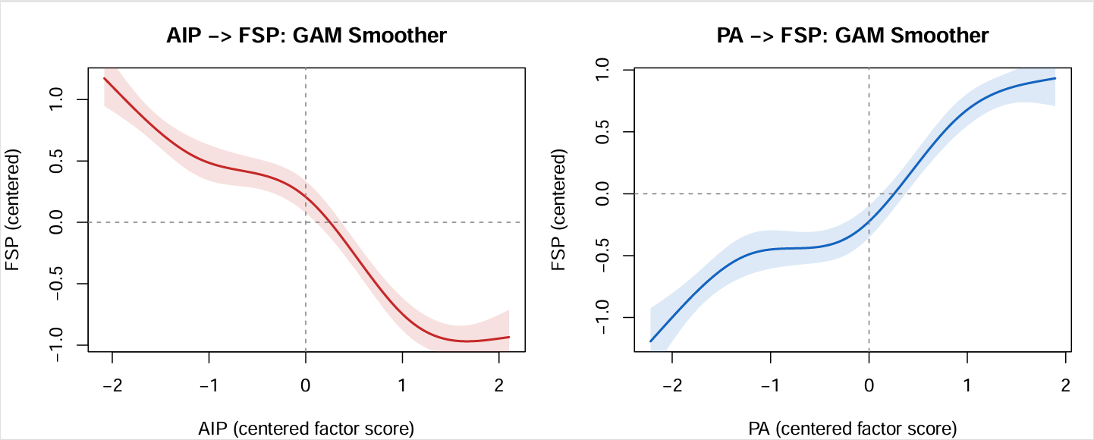
Note. GAM smoothers with 95% pointwise confidence bands. Left: AIP–FSP (monotonically decreasing with slight curvature at moderate levels). Right: PA–FSP (approximately linear positive). Smoothers are based on the analytic sample (N = 522) and are presented for visual inspection of unconditional functional form prior to moderation analysis.
Supplementary Figure S2
Conditional AIP–FSP Relationships at Three DR Levels (Separate Panels)
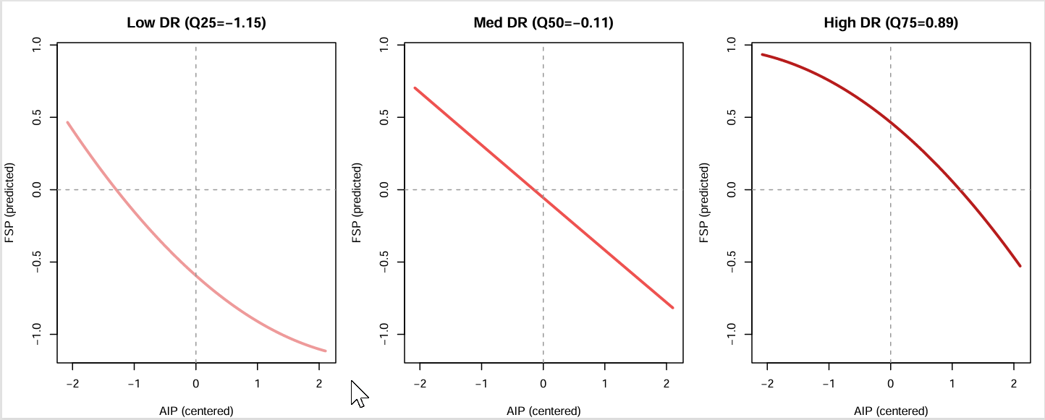
Note. Left: Low DR (Q25 = 1.99) — U-shape. Center: Medium DR (Q50 = 3.03) — approximately monotonically decreasing. Right: High DR (Q75 = 4.03) — inverted-U, AIP* = 0.08 (raw scale). Consistent with the significant AIP² × DR interaction (b = −0.060, p < 0.001).
Supplementary Figure S3
Conditional PA–FSP Relationships at Three DR Levels (Separate Panels)
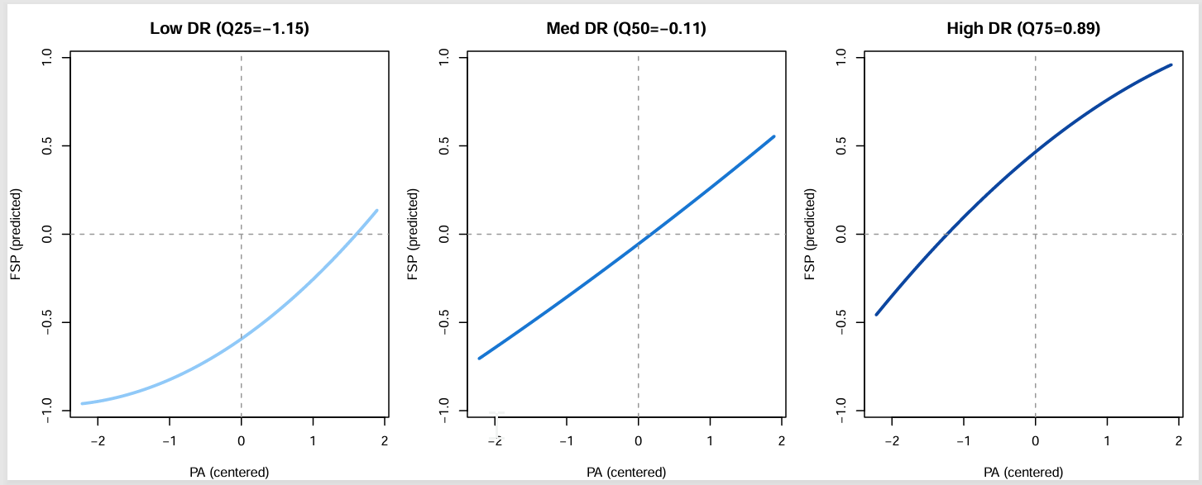
Note. Left: Low DR (Q25 = 1.99) — convex (U-shape). Center: Medium DR (Q50 = 3.03) — near-linear positive. Right: High DR (Q75 = 4.03) — concave (inverted-U). Consistent with the significant PA² × DR interaction (b = −0.045, p < 0.001; H4 supported).

